Starting Windows Explorer and Maximizing Its Window
To explore the files and folders on the computer, start Windows Explorer and maximize its window by performing the following steps.

STEPS TO START WINDOWS EXPLORER AND MAXIMIZE ITS WINDOW
① Right-click the My Computer icon on the desktop and then point to Explore on the shortcut menu.
The My Computer icon is highlighted, a shortcut menu displays, and the Explore command is highlighted ().

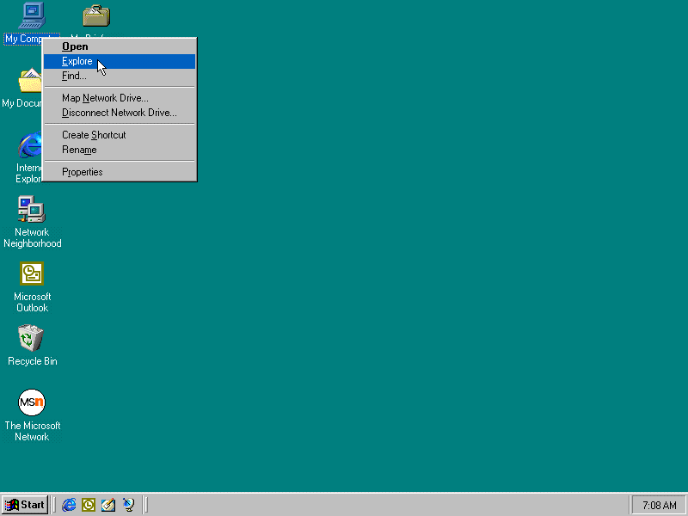

② Click Explore and then click the Maximize button on the Exploring – My Computer title bar.
The Exploring – My Computer window opens and is maximized. The recessed Exploring – My Computer button is added to the taskbar button area ().

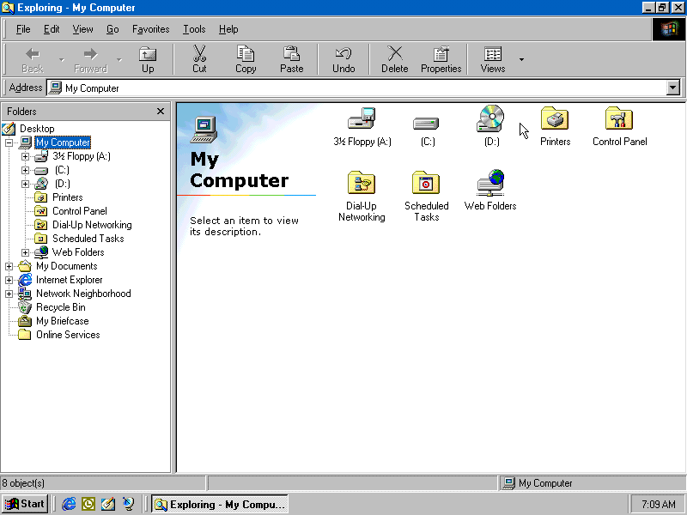

The Exploring – My Computer Window
When you start Windows Explorer by right-clicking the My Computer icon and then clicking the Explore command on the shortcut menu, Windows 98 opens the Exploring – My Computer window. The menu bar contains the File, Edit, View, Go, Favorites, Tools, and Help menu names. These menus contain commands to organize and work with the drives on the computer and the files and folders on those drives. Below the menu bar is the Standard Buttons toolbar.

The main window is divided into two panes separated by a bar. The left pane of the window, identified by the folders title, contains a hierarchy of folders on the computer. The right pane of the window displays the contents of My Computer. In the previous figure, the Contents pane contains the icons and folder names of eight folders in the My Computer Folder: 3½ Floppy (A:), (C:), (D:), Printers, Control Panel, Dial-Up Networking, Scheduled Tasks, and Web Folders. These folders may be different on your computer. You can change the size of the Folders and Contents panes by dragging the bar that separates the two panes.
Each folder in the Folders pane is represented by an icon and folder name. The first folder, consisting of an icon and the Desktop folder name, represents the desktop of the computer. The seven folders indented and aligned below the Desktop folder name (My Computer, My Documents, Internet Explorer, Network Neighborhood, Recycle Bin, My Briefcase, and Online Services) are connected to the vertical line below the Desktop icon. These folders correspond to seven of the nine icons displayed on the left edge of the desktop. These folders may be different on your computer.
Windows 98 displays a minus sign (-) in a box to the left of an icon in the Folders pane to indicate the corresponding folder contains one or more folders that are visible in the Folders pane. These folders, called subfolders, are indented and aligned below the folder name.
In the previous figure, a minus sign precedes the My Computer icon, and eight subfolders are indented and display below the My Computer folder name. The eight subfolders (3½ Floppy (A:), (C:), (D:), Printers, Control Panel, Dial-Up Networking, Scheduled Tasks, and Web Folders) correspond to the eight folders in the Contents pane. Clicking the minus sign, referred to as collapsing the folder, removes the indented subfolders from the hierarchy of folders in the Folders pane and changes the minus sign to a plus sign.
Windows 98 displays a plus sign (+) in a box to the left of an icon to indicate the corresponding folder consists of one or more subfolders that are not visible in the Folders pane. In the previous figure, a plus sign precedes the first three icons indented and aligned below the My Computer name (3½ Floppy (A:), (C:), and (D:) icons). Clicking the plus sign, referred to as expanding the folder, displays a list of indented subfolders and changes the plus sign to a minus sign.
If neither a plus sign nor a minus sign displays to the left of an icon, the folder does not contain subfolders. In the previous figures, the Printers, Control Panel, Dial-Up Networking, Scheduled Tasks, Recycle Bin, and My Briefcase icons are not preceded by a plus or minus sign and do not contain subfolders.
The status bar at the bottom of the Exploring – My Computer window indicates the number of folders, or objects, displayed in the Contents pane of the window (8 object(s)). Depending on the objects displayed in the Contents pane, the amount of disk space the objects occupy and the amount of unused disk space also may display on the status bar. If the status bar does not display in the Exploring – My Computer window on your computer, click View on the menu bar and then click Status Bar.
In addition to right-clicking the My Computer icon to use Windows Explorer to explore your computer, you also can use Windows Explorer to examine different aspects of your computer. Right-click the Start button on the taskbar and then click Explore, or right-click the My Documents, Internet Explorer, Network Neighborhood, Recycle Bin, My Briefcase, and Online Services icon on the desktop.

Displaying the Contents of a Folder
In the previous figure, the Contents pane contains the subfolders in the My Computer folder. In addition to displaying the contents of the My Computer folder, the contents of any folder in the Folders pane can be displayed in the Contents pane. Perform the following steps to display the contents of the (C:) folder.

STEPS TO DISPLAY THE CONTENTS OF A FOLDER
① Point to the (C:) folder name in the Folders pane of the Exploring – My Computer window ().

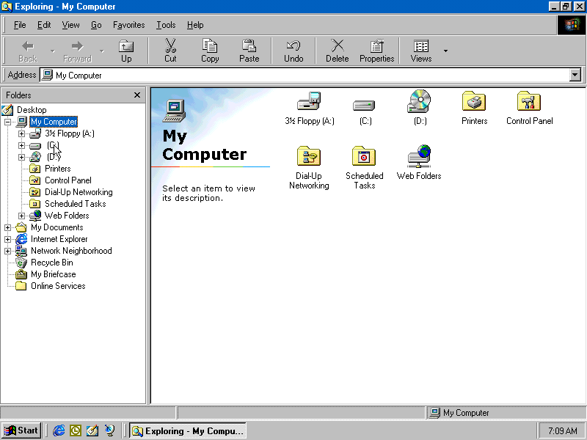

② Click the (C:) folder name.
The highlighted (C:) folder name displays in the Folders pane, the contents of the (C:) folder display in the Contents pane, the window title and button in the taskbar button area change to reflect the folder name, and the messages on the status bar change ().

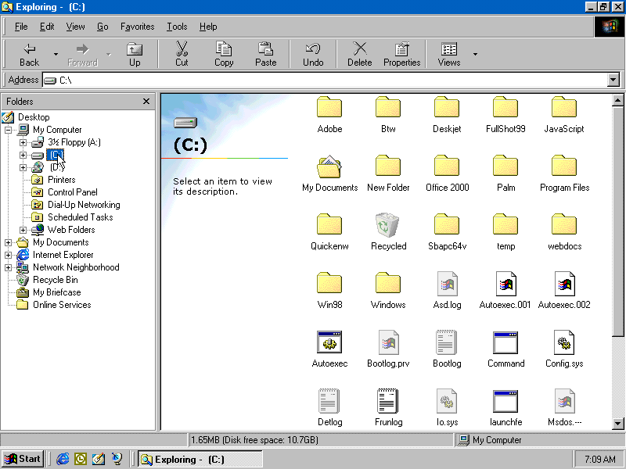

In addition to displaying the contents of the (C:) folder, you can display the contents of the other folders by clicking the corresponding icon or folder name in the Folders pane. The contents of the folder you click then will display in the Contents pane of the window.

Expanding a Folder
Currently, the (C:) folder is highlighted in the Folders pane of the Exploring – (C:) window, and the contents of the (C:) folder display in the Contents pane. Windows 98 displays a plus sign (+) to the left of the (C:) icon to indicate the folder contains subfolders that are not visible in the hierarchy of folders in the Folders pane. To expand the (C:) folder and display its subfolders, perform the following steps.

STEPS TO EXPAND A FOLDER
① Point to the plus sign to the left of the (C:) icon in the Folders pane ().

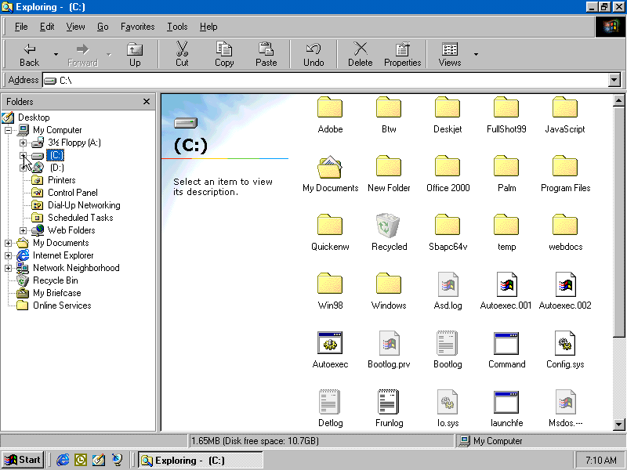

② Click the plus sign to display the subfolders in the (C:) folder.
A minus sign replaces the plus sign preceding the (C:) icon, a vertical scroll bar displays, and the (C:) folder expands. The window title and the files and folders in the Contents pane remain unchanged ().

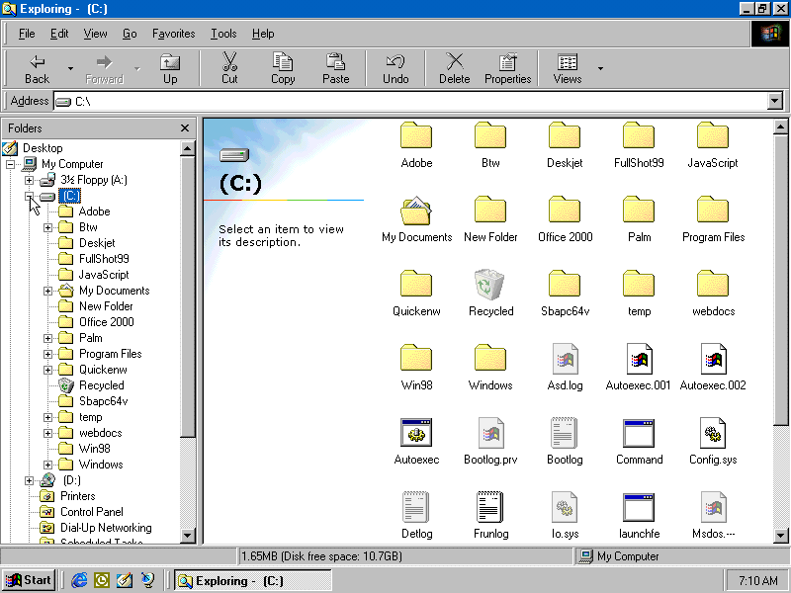

The subfolders in the expanded (C:) folder shown in the previous figure are indented and aligned below the (C:) folder name. A closed folder icon and folder name identify each subfolder in the (C:) folder.

Collapsing a Folder
Currently, the subfolders in the (C:) folder display indented and aligned below the (C:) folder name. Windows 98 displays a minus sign (-) to the left of the (C:) icon to indicate the folder is expanded. To collapse the (C:) folder and then remove its subfolders from the hierarchy of folders in the Folders pane, perform the following steps.

STEPS TO COLLAPSE A FOLDER
① Point to the minus sign preceding the (C:) icon in the Folders pane ().

② Click the minus sign to display the (C:) folder without its subfolders.
A plus sign replaces the minus sign preceding the (C:) icon and the subfolders in the (C:) folder are removed from the hierarchy of folders ().

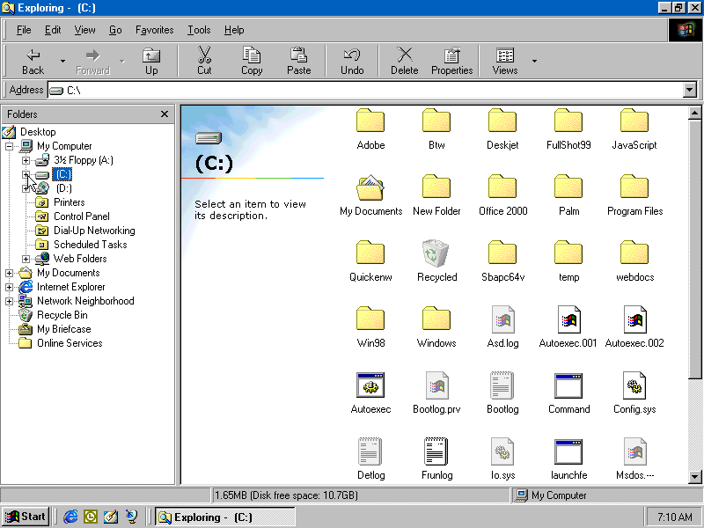

Quitting Windows Explorer
After completing your work with Windows Explorer, you should quit Windows Explorer. Perform the following steps to quit Windows Explorer.

STEPS TO QUIT WINDOWS EXPLORER
① Point to the Close button on the Exploring window title bar ().

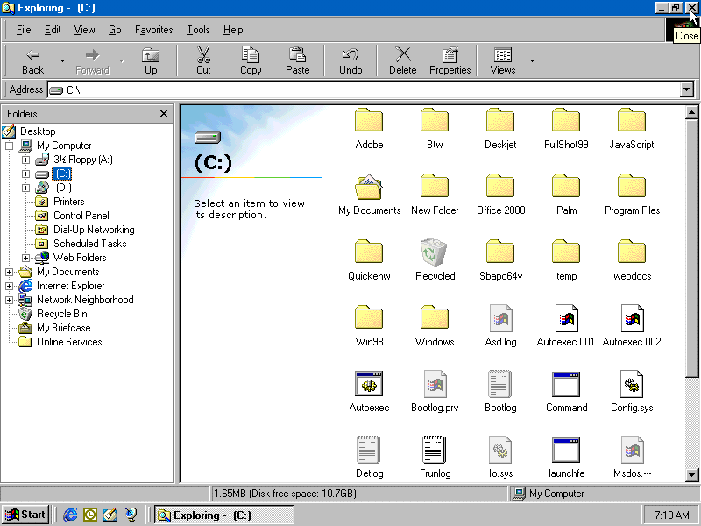

② Click the Close button.
Windows 98 closes the Windows Explorer window and quits Windows Explorer.

